Functional Specification – Product Limit Monitoring Report

Export-Import Bank of Thailand

|  |  |
| --- | --- |
| Project Code: | <EXPJ.B.PJ.TH.EXIMTH*CBS_IMP.CC> |
| Reference: | <Client BZ Reference and Description> |
| Release: | 2.0 |
| Status: | Released for External Distribution |
| Date | 6-Sep-23 |

Contents

Introduction 4

Functional Summary 5

Functional Specification 5

1. 1. ENT-FS09 – Product Limit Monitoring Report 5

1.1. Purpose 5

1.2. Background / Functional Requirements 5

1.3. Supported Sample Transaction and Case from Customer 5

1.4. Menu Modification 5

1.5. Screen Layout and Data Sheet 5

1.6. Business Rule / Business Logic 6

1.7. To-be Processing 6

1.8. File /API Layout and Data Sheet 6

1.9. Report Layout and Data Sheet 7

1.10. Additional Impacts 9

Document Acceptance & Release Notice

This is a managed document. Changes will only be issued as a complete replacement document covered by a release notice. All replaced documents shall be destroyed immediately and copies of any obsolete forms destroyed. This document has not been released for use until authorized by the Manager/Project Manager.

This is release **2.0** of the document.

|  |  |  |  |
| --- | --- | --- | --- |
| Reviewed & Approved |  | Date |  |
|  | | | |
| Accepted |  | Date |  |
|  | |  |  |
| Authorized |  | Date |  |
|  | | | |

Build Status

|  |  |  |  |  |
| --- | --- | --- | --- | --- |
| Release | Date of Release | Prepared by | Reviewed by | Comments |
| 1.0 | 28 August 2023 | Emy Bartolome | Marites Magsajo |  |
| 1.1 | 31 August 2023 | Emy Bartolome | Marites Magsajo | Updated section 1.5 to include 2 fields requested by EXIM Product Team |
| 2.0 | 06 September 2023 | Emy Bartolome | Marites Magsajo | Release Version |

# 

# Introduction

CBS Foundation and Enterprise workshop activity was conducted at the Export-Import Bank (EXIM) of Thailand premises which highlighted CBS core features in terms of general usability, reference data set up, cross product services, including Customer, Collateral, Limits and Common Utilities. It also covered main integration points for EXIM CRM/LOS into CBS Customer and Limits modules respectively. Gaps were also identified during this stage, hence Functional Specifications documentation to rectify the gaps are prepared for review and approval by EXIM business module leads and stakeholders.

Abbreviations

The following list defines the abbreviations used in this document.

|  |  |
| --- | --- |
| EXIM | Export Import Bank of Thailand |
| TOR | Terms of Reference |
| AS/400 | EXIM Core Legacy System |
| LOS | EXIM Loans Origination System |
| CRM | EXIM Customer Relations Module |
| SSI | Silverlake Symmetri |
| CBS | Silverlake Symmetri Core Banking System |
| CSD | CBS Common Static Data Module |
| ENT | CBS Enterprise Modules |
| MCL | CBS Customer Module |
| LMT | CBS Limits Module |
| BPM | CBS Business Process Management |
| LND | CBS Lending Module |
| DEP | CBS Deposits Module |
| GFT | CBS Global Funds Transfer Module |
| BDS | Branch Delivery System |

References

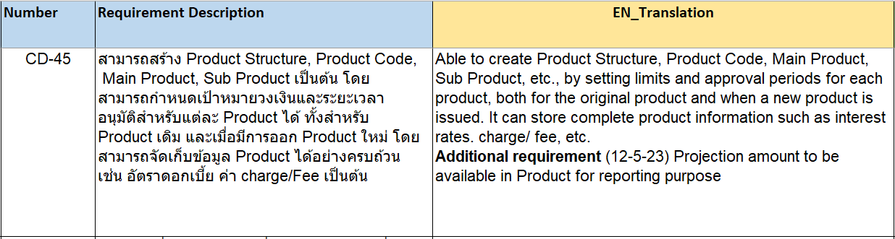

# Functional Summary

This section provides a functionality list of the software product or any modifications on existing Symmetri CBS product.

|  |  |  |
| --- | --- | --- |
| ID | Title/Summary | References |
| FS_EXIMTH_ENT_FS09 | Product Limit Monitoring Report | TOR |

# Functional Specification

## 1. ENT-FS09 – Product Limit Monitoring Report

### Purpose

The purpose of this document is to provide the solution through functional specification resulting from the requirement of TOR # CD-45 which states that system should be able to create and maintain product, set limit, approval period, including other configurations required for the product.

### Background / Functional Requirements

#### Create Product Structure and Approval Period

System should allow creation of product structure, formulate product code, having main product and sub classification of product with option to indicate approval or activated period of the product.

This will be supported using the existing product definition screens of CBS Lending and Deposits module.

#### Setting of Limit Amount for Product Availment and Monitoring

System should have provision to allow user to set limits for the product, with option to indicate approval period.

This will be supported by the introduction of new field at CBS Limit Facility Structure level to capture overall product level limit currency and amount. This solution includes option of generating report that will reflect consolidated approved limit facility amounts for a given limit facility.

#### Store Product Information and Configuration

System should store required product information, including interest rates, charges, fees.

This will be supported by existing product definition screens of CBS Lending and Deposits module.

### Supported Sample Transaction and Case from Customer

ธุรกรรมและกรณีตัวอย่างที่รองรับจากลูกค้า

Not Applicable

ไม่จําเป็น

### Menu Modification

การปรับเปลี่ยนเมนู

Not Applicable

ไม่จําเป็น

### Screen Layout and Data Sheet

Existing Facility Structure Screen

New fields to indicate Overall product level limit monitoring currency and amount will be introduced:

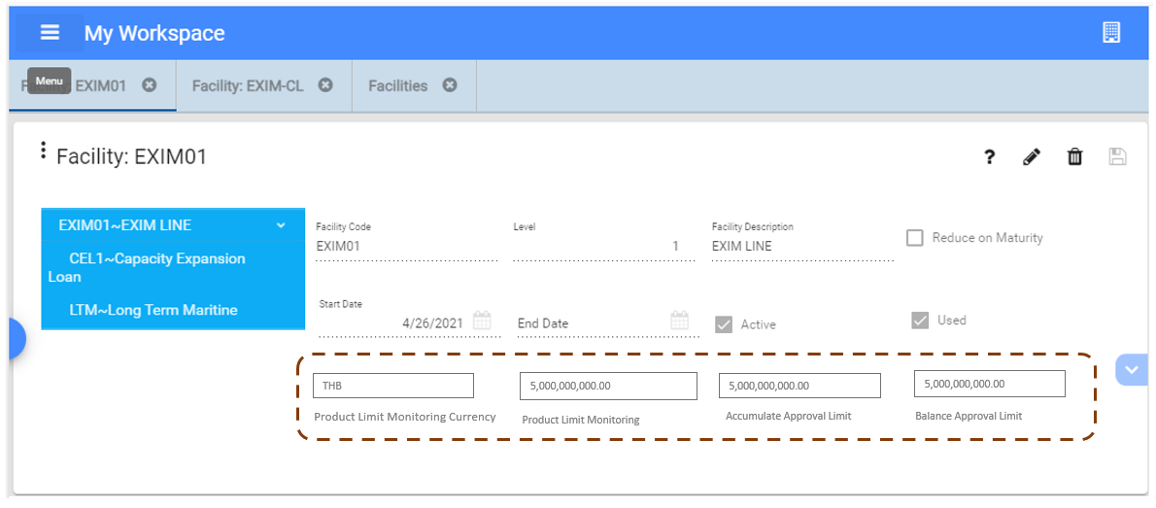

Screen Data Sheet

Type - M (Mandatory), O (Optional), C (Conditional), A (Amend), D (Display), Q (Query)

| Screen/Report Field Name/Attributes | Type | Source/Validations |
| --- | --- | --- |
| Product Limit Monitoring Currency | **O** | This will be the currency for the overall approved product or credit line. |
| Product Limit Monitoring Amount | **C, O, A** | This field will be mandatory once limit monitoring currency is captured  This field will be used to indicate the overall product limit monitoring amount  This will identify the target limit of the product (the amount can be changable based on the discussion from product committee or MC)  Field value can be updated anytime based on user discretion. |
| Accumulative Approval Limit Amount | **O, A** | This field is user-defined accumulate approval limit (have already sign contract and the limit is available for drawdown ) |
| Balance Approval Limit Amount | **O, A** | Balance Approval Limit (can be changable based on additional approved amount from the committee or cancel the limit of the product).  Field value can be updated anytime based on user discretion given below sample business scenarios:  Business Case: BIZ loan have target limit which is 5000 MB  Case 1: Customer approve for limit 100 MB (signed contract and limit is available for drawdown) but not drawdown yet ,and then cencel the limit. The amount of approved limit will be added back to the Balance Approval Limit (Field C)  Case 2: Customer approve for limit 100 MB (signed contract, etc.) drawdown for 60 MB but cancel the availalble limit 40 MB. The available amount will be added back to the Balance Approval Limit (Field C) |

### Business Rule / Business Logic

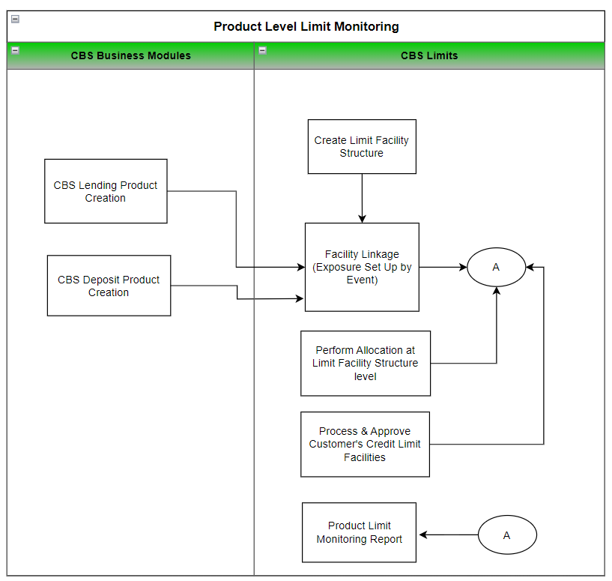

In order for Overall Product Limit monitoring is to be performed, the following steps will be undertaken:

#### CBS Business Modules

Business Leads and designated domain experts will create products at business module level using one-time static screen set up of Lending and Deposits module. This is where the product structure or code, sub-classification or sub-type, defaulting rules and other configuration will be performed. It can also include information on interest rates, interest type, spread rates will be captured.

#### CBS Limits

Designated Limits business lead will be performing the following:

1. Design or formulate the limit facility structure of the bank. This will be in line with the products from all business domains within CBS, including external systems where credit risk exposure will be tracked and monitored by CBS Limits module.
2. Facility Linkage table contains the rules to specify which limit facility will be utilized and monitored (in terms of exposure) based on a given product code (loan type/sub type, deposit account type) will be performed as part of static set up activity (one-time procedure for master data creation). These information will also be used by Product Limit Monitoring report in order to identify the scope of products given this limit facility code or credit line.
3. Product Limit allocation for a given credit line will be indicated by Product team that will be used for monitoring purposes.
4. Customer’s limit facilities will be interfaced by LOS (for Loan and OD) and AS/400 (for Trade facilities). Once Limit Facilities are marked as verified, this will be used as utilized portion of overall product level limit and will be consolidated in Approved Limit Amount of Product Limit Monitoring report.

### To-be Processing

#### Master Data Configuration

Data which are captured as one-time set up, used by transaction as and when required are part of configuration activity of CBS implementation. The set ups are either done at Foundation/Enterprise level which is used across the system, or it can be at business module level: Deposit, Lending and Limits.

##### Deposits

To formulate the deposit account type product structure, code, nature of account to indicate if it is term, current or savings account will be handled at Deposit Account Type definition screen of Deposits Module.

##### Lending

To be able to set up product structure of loan accounts, loan type/sub type and all required defaulting and configuration will be handled at Loan Type definition screen of Lending Module.

##### Limit Facility Structure

Part of static set up activity is to capture all limit facilities (credit line) code, description, facility level, approval or active period (by indicating start/end date). This limit facility code will be used to link to appropriate products offered at business module level where limit exposure tracking will be performed.

##### Exposure Set up by Event (Limit FAcilty Linkage)

This set up is to be performed in order to establish link between product offering and the limit facility where limit exposure tracking is to be done by CBS.

##### Limit Allocation at Facility Structure level

Product Limit allocation for a given limit facility code will be captured and maintained at facility structure levelindicated by Product team that will be used for monitoring purposes,

#### Operational Process Flow

##### Process & Approve Customer Credit Limit Facility

Customer’s limit facilities will be granted and information will be made available in CBS. Once the limit facility verified flag is set to Y, it means the limit facility has been approved and ready for utilization. The approved limit amount will be the basis of reflecting availment of product at Product Limit Monitoring report.

#### Monitoring

##### Product Limit Monitoring Report

A new report will be made available in CBS. Details can be found in Report Layout and Data sheet section of this FSD.

##### Product Limit Monitoring via Alerts

In order to have online tracking of product limit allocation, an event can be generated that will be triggered once utilized amount is greater than approved / allocated amount that will result to negative product limit balance. Once the event is generated, system will produce the required alert and notification to be published to designated participants or subscribers of this alert.

### File /API Layout and Data Sheet

Not Applicable

### Report Layout and Data Sheet

#### Product Limit Monitoring Report

##### Report Parameter Criteria

| Report Parameter Field | Source/Validations |
| --- | --- |
| Facility Code | This is limit facility code based on granted / approved limit for the customer |
| Report File Type | CSV, HTLM, XLSX, etc/ |

##### Report Layout

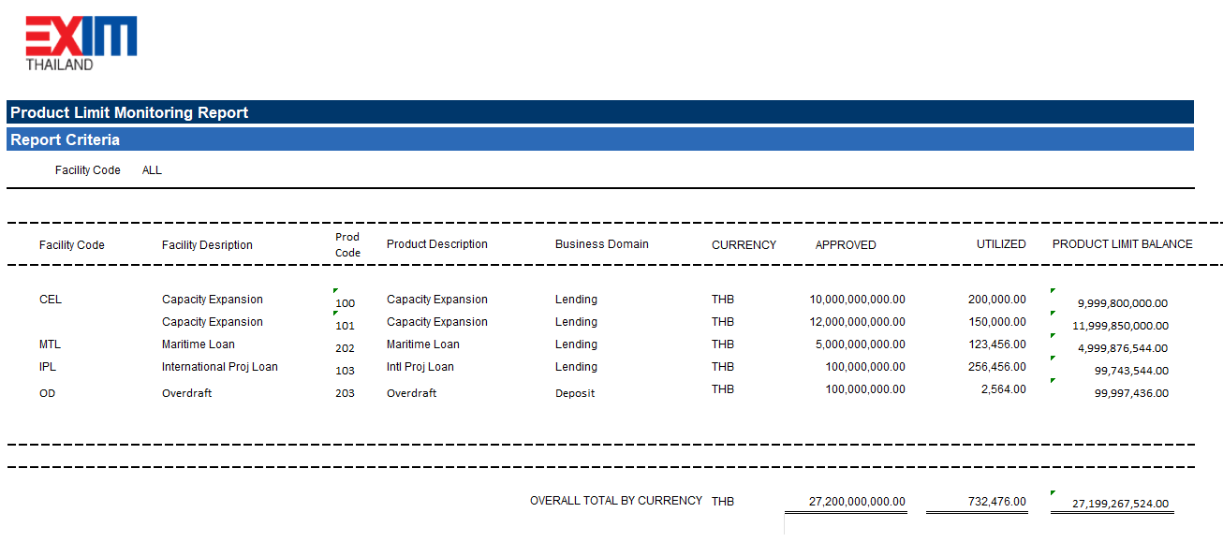

##### Report Data Sheet

| Report Field Name/Attributes | Source/Validations |
| --- | --- |
| **Header** |  |
| Report Criteria | Facility Code |
| **Detail** |  |
| Facility Code | Limit Facility Code |
| Facility Description | Description of Limit Facility Code  Source: Facility Structure |
| Product Code | Linked product for a given limit facility code  Source: Facility Linkage (Exposure Set up by Event) |
| Product Description | Product Code Description |
| Business Domain | Linked business domain of product  Source: Facility Linkage (Exposure Set up by Event) |
| Currency | Approved Limit Currency  Source: Facility structure (new field) |
| Approved | Approved Amount  Source: Facility structure (new field) |
| Utilized | Consolidated effective limit amount for the facility code  Source: Client Limit Facility |
| Product Limit Balance | Derived amount:  Approved Amount less utilized  Source: Limit Facility structure and Client Limit Facility |
| **Footer** |  |
| Overall Total Approved | Sum of total approved |
| Overall Total Utilized | Sum of total utilized |
| Overall total Product Limit Balance | Sum of product limit balance |

### Additional Impacts

#### System Interface requirement /Integration

Not applicable

#### Migration

Not applicable

#### Fit/Gap Analysis Report

|  |  |  |
| --- | --- | --- |
| ลำดับ | คำอธิบายความต้องการ/ข้อกำหนด | คำอธิบายความต้องการ/ข้อกำหนด |
| CD-45 | สามารถสร้าง Product Structure, Product Code, Main Product, Sub Product เป็นต้น โดยสามารถกำหนดเป้าหมายวงเงินและระยะเวลาอนุมัติสำหรับแต่ละ Product ได้ ทั้งสำหรับ Product เดิม และเมื่อมีการออก Product ใหม่ โดยสามารถจัดเก็บข้อมูล Product ได้อย่างครบถ้วน เช่น อัตราดอกเบี้ย ค่า charge/Fee เป็นต้น | Able to create Product Structure, Product Code, Main Product, Sub Product, etc., by setting limits and approval periods for each product, both for the original product and when a new product is issued. It can store complete product information such as interest rates. charge/ fee, etc.  Additional requirement (12-5-23) Projection amount to be available in Product for reporting purpose |